**Fitzgerald Christmas Letter 2022, Some Things Return to Normal**

It is easy, at times, to forget the disruptive years of the Covid pandemic, as things slowly seemed to turn back to normal. We found ourselves easing back into activities outside the bubbles we were in for the past two years. It hasn't been all bread and roses, but we are grateful for so much.

It’s good have our daughter Liz back in the house! She'd been staying in her own studio apartment, but it made sense to all of us to have her back. She's now occupying the room on the third floor which we had been using as our attic library. But just because she's up there with her two cats, don't call her the madwoman in the attic. Those strange sounds you hear are her playing online D&D with her friends far and wide. It's so good to be able to hang out with her again.

We'd hoped we'd have news that son Mark's fiancé, Lak, would be in the U.S. by now. He's hoping to come on a K1 visa (the fiancé visa). But not quite yet. The paperwork is coming along, but there are two big bureaucracies involved, Covid is resurging in China, and Hofstadter's Law says it a project always takes longer to do than expected, even when you take Hofstadter's Law into account. We do hope that he'll arrive in the first quarter of 2023, and at least a quick civil ceremony will happen soon after. Stay tuned!

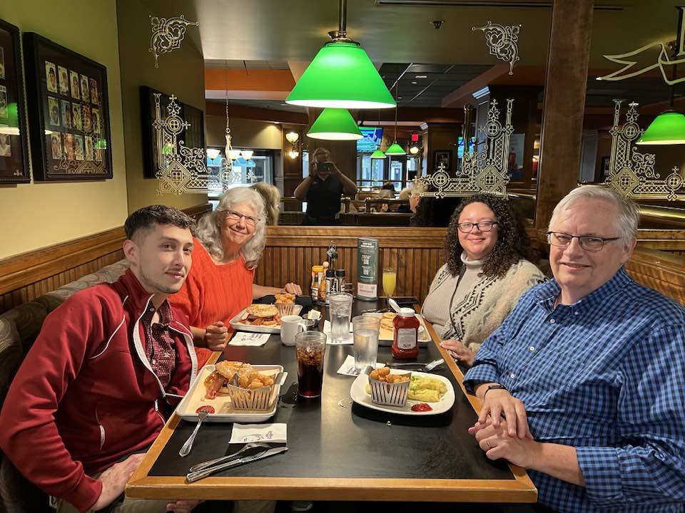Will started the year as a retired person. He got caught up in the Wordle craze and spent a little bit too much time programming solvers and variants (you might enjoy wordle10.com, a ten-letter variant). Perhaps he was not ready for retirement? He returned to GitHub, to his old position and team, after several months away, and is again working full time. He did it just before inflation started ticking up—prescient, right? He's almost always glad to be back working. He's also been enjoying baking bread a bit more, including taking an online course.

But it's Bess who had a lot going on this year! She started a monthly neighborhood activity, Hill Stroll, that brings together people on the last night of the month to walk the neighborhood and engage in some activity each month: porch music, picnic in the park, searching for fireflies. She also discovered vernal pools, which are ponds that show up in spring and go away by summer. They have their unique ecology but are generally unprotected. There’s a project to inventory vernal pools on state land, and this is just the kind of thing Bess loves to do. She was also a camp counselor at a Mennonite Disaster Services family camp and spent a lovely week pounding nails and telling tales. And she traveled to Manistique, Michigan to help with Bible school there!

We are also very grateful to have found a church home after being without a local church since the beginning of the pandemic. To our surprise, it is a largish Lutheran church, formal in its worship. The people we have met have been kind and inviting, and we already had good friends there. We have joined the choir, and it’s good to be able to sing.

We had two vacations this year. One was a winter staycation. The other was a wonderful trip in August to the Lake Nipigon area in Ontario, north of Lake Superior. We saw so many beautiful things. Will also flew down to Atlanta, his first post-pandemic airplane trip, to sing Sacred Harp. He didn’t get Covid, but (as we all know now), there are other respiratory illnesses out there, and he got one of those, and was uncomfortable for a while. Bess did get Covid, coming down with a mild case right after our Ontario trip. The week that everything shut down for Covid in 2020, we had plans to travel to Chicago with friends Sam and Beth. We finally were able to make that date happen, worshipping at the Church of the Ascension and visiting a small Polish restaurant we’d wanted to revisit.

Other important miscellanea: Will’s oldest brother turned 70; celebrating Bess’s sister Anne and her husband Sandy’s 50 anniversary and Sandy’s retirement; so many friends and relations are in the midst of retiring or thinking about retiring; we continue to be nourished by our monthly potluck group (and how great to be able to meet in person this year); the “Lord of the Rings” themed potluck where Bess went as a beautiful Goldberry, and Bess and Will were only one of two Tom Bombadil/Goldberry pairs; Will’s knee arthritis catching up with him, and we’re looking forward to surgery in the new year; kind of accidentally buying and selling a BMW; we continue to enjoy sharing our house with Helder, who has been working many, many hours and has nearly paid for a house back in Guatemala, and who bought a bright yellow Mustang, the dream of every 20-something male; gratitude that when Helder hit a deer with the Mustang only the Mustang (and the deer, probably) were damaged; a patristics reading group that Will has enjoyed held with colleagues from work, who are all surprised that there are other people at GitHub who want to read early Christian works together; Will continues to preach from time to time via Zoom; still in love after all these years.

We hope your 2023 is flourishing!

Best, Will & Bess